**Milestone Report 1**

**Law Firm BPR Team**

**Project Name: Law Firm Billing Project**

**Report Date: October 18, 2012**

Team Members:

Albert Badalyan Database Administrator

Colin Kay Project Manager

Kaleb Martens GUI Developer

Pagoda Pang Technical Writer

Back End Design**:**

Software: Visual Basic 2012 with Lightswitch, Microsoft SQL Express, Microsoft Access,

Database: The database is the key component in this project; the final project will have an application to allow data entry onto a database. The database will be hosted on a machine in the office to supply on the fly data entry. We used Microsoft Access, to help us design the data base due to the GUI it has. After we had created the database it was later converted into Microsoft SQL Express database, where we currently change anything that needs fixing. The use of Microsoft SQL Express is for the database engine. From what we gathered from the interview, the application needs to be used by multiple users. So we decided to use SQL Express as the engine, since our DBA has experience with it.

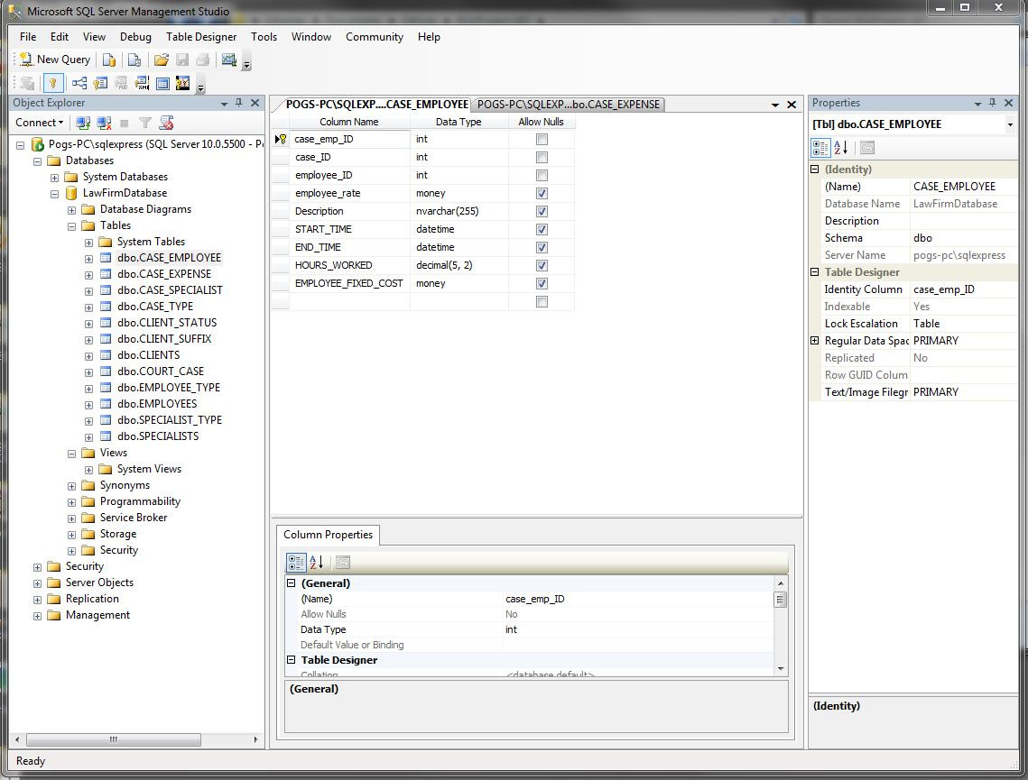

Application Design: The team is using Visual Basic 2012 with Lightswitch. This software allows us

to have a GUI already in place, thus we can concentrate more on data validation. Using this software allows us to connect to a database with an interface we can test on. We can focus on putting data where it's needed and calculating it. This software also allows applications to be run on multiple machines, and to write to the database live provided there is sufficient equipment.

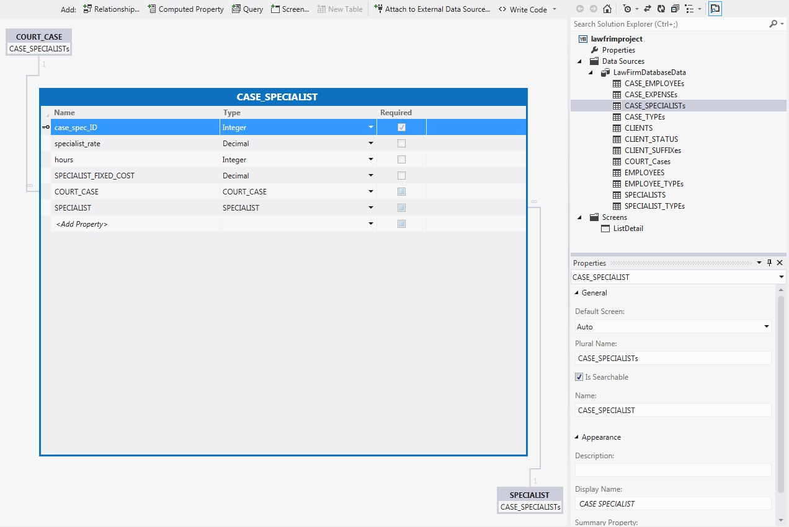

Database:

During the beginning phases of the project, this was one our major undertakings. We spent quite a bit of time asking our sponsors what the system needed to do. After many questions, we had an idea on what the attorneys wanted. We spent several weeks designing the database based on the user requirements, and from a forum they gave us. After a few revisions we eventually came to a database we all agreed that was correct for this project.

This is what we currently have after several discussions on how the application should work, and after some testing. The database is currently a work in progress; things might change over time as we figure out more.

**Database Schema:**

|  |
| --- |
| RELATIONSHIPS |
| MANY employees TO MANY cases  ONE client TO MANY cases  MANY specialists TO MANY cases  MANY cases TO MANY expenses |

|  |
| --- |
| ENTITIES |
| CLIENTS, EMPLOYEES, COURT_CASE, SPECIALISTS, CASE_EMPLOYEE, CASE_SPECIALIST, CASE_EXPENSES  LOOKUPS:  CLIENT_STATUS  CLIENT_SUFFIX  EMPLOYEE_TYPE  CASE_TYPE  SPECIALIST_TYPE |

|  |
| --- |
| DBDL |
| **CLIENTS**(CLIENT_ID, CLIENT_STATUS_ID, APP_RET_DATE , CLIENT_SUFFIX_ID, FIRST_NAME, LAST_NAME, DOB, STREET_ADDRESS, CITY, STATE, ZIP, PHONE, JID_CDC, SSN, DRIVER_LICENSE, EMAIL )  PK CLIENT_ID  FK CLIENT_STATUS_ID 🡺 CLIENT_STATUS  FK CLIENT_SUFFIX_ID 🡺 CLIENT_SUFFIX  **CLIENT_STATUS**(CLIENT_STATUS_ID, CLIENT_STATUS)  PK CLIENT_STATUS_ID  **CLIENT_SUFFIX**(CLIENT_SUFFIX_ID, CLIENT_SUFFIX)  PK CLIENT_SUFFIX_ID  **EMPLOYEES**(EMPLOYEE_ID, EMPLOYEE_TYPE_ID, FIRST_NAME, LAST_NAME, DOB, STREET_ADDRESS, CITY, STATE, ZIP, PHONE, EMAIL)  PK EMPLOYEE_ID  FK EMPLOYEE_TYPE_ID 🡺 EMPLOYEE_TYPE  **EMPLOYEE_TYPE**(EMPLOYEE_TYPE_ID, EMPLOYEE_TYPE)  PK EMPLOYEE_TYPE_ID  **COURT_CASE**(CASE_ID, CASE_NUMBER, CASE_CATEGORY_ID, CLIENT_ID, CASE_TYPE, CASE_TITLE, CASE_DATE, CLIENT_RELATIONSHIP, NOTES, CLIENT_RELA_ID,)  PK CASE_ID  FK CASE_CATEGORY_ID 🡺 CASE_CATEGORIES  FK CLIENT_ID 🡺 CLIENTS  FK CLIENT_RELA_ID 🡺 CLIENT_RELATIONSHIP  **CASE_TYPE**(CASE_CATEGORY_ID, TITLE, AMOUNT)  PK CASE_CATEGORY_ID  **SPECIALISTS**(SPECIALIST_ID, FIRST_NAME, LAST_NAME, PHONE, EMAIL, STREET_ADDRESS, CITY, STATE, ZIP SPECIALIST_TYPE_ID)  PK SPECIALIST_ID  FK SPECIALIST_TYPE_ID 🡺 SPECIALIST_TYPE  **SPECIALIST_TYPE**(SPECIALIST_TYPE_ID, SPECIALIST_TYPE)  PK SPECIALIST_TYPE_ID  **CASE_EMPLOYEE**(CASE_EMP_ID, CASE_ID, EMPLOYEE_ID, EMPLOYEE _RATE, START_TIME, END_TIME, HOURS_WORKED, EMPLOYEE_FIXED_COST)  PK CASE_EMP_ID  FK CASE_ID 🡺 COURT_CASE  FK EMPLOYEE_ID 🡺 EMPLOYEES  **CASE_SPECIALIST**(CASE_SPEC_ID, CASE_ID, SPECIALIST_ID, SPECIALIST_RATE, HOURS, SPECIALIST_FIXED_COST)  PK CASE_SPEC_ID  FK CASE_ID 🡺 COURT_CASE  FK SPECIALIST_ID 🡺 SPECIALISTS  **CASE_EXPENSES**(CASE_EXP_ID, CASE_ID,DESCRIPTION, EXPENSE_COST)  PK CASE_EXP_ID  FK CASE_ID 🡺 COURT_CASE  **CLIENT_RELATIONSHIP**(CLIENT_RELA_ID, CLIENT_RELATIONSHIP)  PK CLIENT_RELA_ID |
|  |

**Entity Relationship Diagram:**

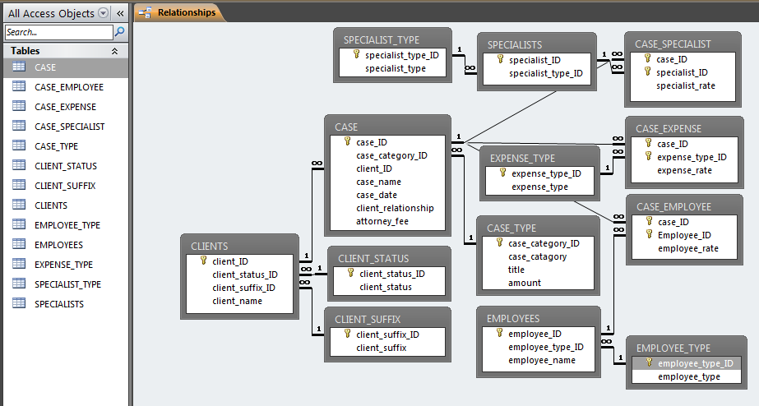

Here are the scripts we used to create the tables within Microsoft SQL Express. Using these scripts allows us to alter tables easier. If we forgot to add an attribute all we have to do is add a few lines to the script and run it in MS SQL Express.

# Database Scripts:

**Table CASE_EMPLOYEE:**

USE [LawFirmDRM22]

GO

/****** Object: Table [dbo].[CASE_EMPLOYEE] Script Date: 9/21/2012 8:35:17 PM ******/

SET ANSI_NULLS ON

GO

SET QUOTED_IDENTIFIER ON

GO

CREATE TABLE [dbo].[CASE_EMPLOYEE](

[case_emp_ID][int]IDENTITY(1,1) NOT NULL,

[case_ID] [int] NOT NULL,

[employee_ID] [int] NOT NULL,

[employee_rate] [money] NULL,

[Description][nvarchar](255) NULL,

[START_TIME][datetime] NULL,

[END_TIME][datetime] NULL,

[HOURS_WORKED][decimal](5,2) NULL,

[EMPLOYEE_FIXED_COST][money] NULL

CONSTRAINT [PK_CASE_EMP_ID] PRIMARY KEY CLUSTERED

(

[case_emp_ID] ASC

)WITH (PAD_INDEX = OFF, STATISTICS_NORECOMPUTE = OFF, IGNORE_DUP_KEY = OFF, ALLOW_ROW_LOCKS = ON, ALLOW_PAGE_LOCKS = ON) ON [PRIMARY]

) ON [PRIMARY]

GO

ALTER TABLE [dbo].[CASE_EMPLOYEE] WITH CHECK ADD CONSTRAINT [FK_CASE_ID] FOREIGN KEY([case_ID])

REFERENCES [dbo].[COURT_CASE] ([case_ID]) on delete cascade

GO

ALTER TABLE [dbo].[CASE_EMPLOYEE] CHECK CONSTRAINT [FK_CASE_ID]

GO

ALTER TABLE [dbo].[CASE_EMPLOYEE] WITH CHECK ADD CONSTRAINT [FK_EMPLOYEE_ID] FOREIGN KEY([employee_ID])

REFERENCES [dbo].[EMPLOYEES] ([employee_ID]) on delete cascade

GO

ALTER TABLE [dbo].[CASE_EMPLOYEE] CHECK CONSTRAINT [FK_EMPLOYEE_ID]

GO

**Table CASE_EXPENSES:**

USE [LawFirmDRM2]

GO

/****** Object: Table [dbo].[CASE_EXPENSE] Script Date: 9/21/2012 8:41:27 PM ******/

SET ANSI_NULLS ON

GO

SET QUOTED_IDENTIFIER ON

GO

CREATE TABLE [dbo].[CASE_EXPENSE](

[case_exp_ID][int] IDENTITY(1,1) NOT NULL,

[case_ID] [int] NOT NULL,

[description][nvarchar](255),

[expense_cost] [money] NULL,

CONSTRAINT [PK_CASE_EXP_ID] PRIMARY KEY CLUSTERED

(

[case_exp_ID] ASC

)WITH (PAD_INDEX = OFF, STATISTICS_NORECOMPUTE = OFF, IGNORE_DUP_KEY = OFF, ALLOW_ROW_LOCKS = ON, ALLOW_PAGE_LOCKS = ON) ON [PRIMARY]

) ON [PRIMARY]

GO

ALTER TABLE [dbo].[CASE_EXPENSE] WITH CHECK ADD CONSTRAINT [FK_CASE_ID3] FOREIGN KEY([case_ID])

REFERENCES [dbo].[COURT_CASE] ([case_ID]) on delete cascade

GO

ALTER TABLE [dbo].[CASE_EXPENSE] CHECK CONSTRAINT [FK_CASE_ID3]

GO

**Table CASE_SPECIALIST:**

USE [LawFirmDRM2]

GO

/****** Object: Table [dbo].[CASE_SPECIALIST] Script Date: 9/21/2012 8:38:22 PM ******/

SET ANSI_NULLS ON

GO

SET QUOTED_IDENTIFIER ON

GO

CREATE TABLE [dbo].[CASE_SPECIALIST](

[case_spec_ID][int] IDENTITY(1,1) NOT NULL,

[case_ID] [int] NOT NULL,

[specialist_ID] [int] NOT NULL,

[specialist_rate] [money] NULL,

[hours][int],

[SPECIALIST_FIXED_COST][money]

CONSTRAINT [PK_CASE_SP_ID] PRIMARY KEY CLUSTERED

(

[case_spec_ID] ASC

)WITH (PAD_INDEX = OFF, STATISTICS_NORECOMPUTE = OFF, IGNORE_DUP_KEY = OFF, ALLOW_ROW_LOCKS = ON, ALLOW_PAGE_LOCKS = ON) ON [PRIMARY]

) ON [PRIMARY]

GO

ALTER TABLE [dbo].[CASE_SPECIALIST] WITH CHECK ADD CONSTRAINT [FK_CASE_ID2] FOREIGN KEY([case_ID])

REFERENCES [dbo].[COURT_CASE] ([case_ID]) on delete cascade

GO

ALTER TABLE [dbo].[CASE_SPECIALIST] CHECK CONSTRAINT [FK_CASE_ID2]

GO

ALTER TABLE [dbo].[CASE_SPECIALIST] WITH CHECK ADD CONSTRAINT [FK_SP_ID2] FOREIGN KEY([specialist_ID])

REFERENCES [dbo].[SPECIALISTS] ([specialist_ID]) on delete cascade

GO

ALTER TABLE [dbo].[CASE_SPECIALIST] CHECK CONSTRAINT [FK_SP_ID2]

GO

Table CASE_TYPE:

USE [LawFirmDRM2]

GO

/****** Object: Table [dbo].[CASE_TYPE] Script Date: 9/21/2012 8:18:47 PM ******/

SET ANSI_NULLS ON

GO

SET QUOTED_IDENTIFIER ON

GO

CREATE TABLE [dbo].[CASE_TYPE](

[case_category_ID] [int] IDENTITY(1,1) NOT NULL,

[case_catagory] [nvarchar](255) NOT NULL,

[title] [nvarchar](255) NULL,

[amount] [money]

CONSTRAINT [PK_CASE_CAT_ID] PRIMARY KEY CLUSTERED

(

[case_category_ID] ASC

)WITH (PAD_INDEX = OFF, STATISTICS_NORECOMPUTE = OFF, IGNORE_DUP_KEY = OFF, ALLOW_ROW_LOCKS = ON, ALLOW_PAGE_LOCKS = ON) ON [PRIMARY]

) ON [PRIMARY]

GO

**Table CLIENT_RELATIONSHIP:**

USE [LawFirmDRM2]

GO

/****** Object: Table [dbo].[CLIENT_RELATIONSHIP] Script Date: 10/8/2012 12:02:25 PM ******/

SET ANSI_NULLS ON

GO

SET QUOTED_IDENTIFIER ON

GO

CREATE TABLE [dbo].[CLIENT_RELATIONSHIP](

[CLIENT_RELA_ID] [int] IDENTITY(1,1) NOT NULL,

[CLIENT_RELATIONSHIP] [nvarchar](255) NULL,

CONSTRAINT [PK_CLIENT_RELA_ID] PRIMARY KEY CLUSTERED

(

[CLIENT_RELA_ID] ASC

)WITH (PAD_INDEX = OFF, STATISTICS_NORECOMPUTE = OFF, IGNORE_DUP_KEY = OFF, ALLOW_ROW_LOCKS = ON, ALLOW_PAGE_LOCKS = ON) ON [PRIMARY]

) ON [PRIMARY]

GO

**Table CLIENT_STATUS:**

USE [LawFirmDRM2]

GO

/****** Object: Table [dbo].[CLIENT_STATUS] Script Date: 9/21/2012 8:13:28 PM ******/

SET ANSI_NULLS ON

GO

SET QUOTED_IDENTIFIER ON

GO

CREATE TABLE [dbo].[CLIENT_STATUS](

[client_status_ID] [int] IDENTITY(1,1) NOT NULL,

[client_status] [nvarchar](25) NOT NULL,

CONSTRAINT [PK_CLIENT_STATUS_ID] PRIMARY KEY CLUSTERED

(

[client_status_ID] ASC

)WITH (PAD_INDEX = OFF, STATISTICS_NORECOMPUTE = OFF, IGNORE_DUP_KEY = OFF, ALLOW_ROW_LOCKS = ON, ALLOW_PAGE_LOCKS = ON) ON [PRIMARY]

) ON [PRIMARY]

GO

**Table CLIENT_SUFFIX:**

USE [LawFirmDRM2]

GO

/****** Object: Table [dbo].[CLIENT_SUFFIX] Script Date: 9/21/2012 8:15:52 PM ******/

SET ANSI_NULLS ON

GO

SET QUOTED_IDENTIFIER ON

GO

CREATE TABLE [dbo].[CLIENT_SUFFIX](

[client_suffix_ID] [int] IDENTITY(1,1) NOT NULL,

[client_suffix] [nvarchar](25) NOT NULL,

CONSTRAINT [PK_CLIENT_SUFFIX_ID] PRIMARY KEY CLUSTERED

(

[client_suffix_ID] ASC

)WITH (PAD_INDEX = OFF, STATISTICS_NORECOMPUTE = OFF, IGNORE_DUP_KEY = OFF, ALLOW_ROW_LOCKS = ON, ALLOW_PAGE_LOCKS = ON) ON [PRIMARY]

) ON [PRIMARY]

GO

**Table CLIENTS:**

USE [LawFirmDRM2]

GO

/****** Object: Table [dbo].[CLIENTS] Script Date: 9/21/2012 8:23:26 PM ******/

SET ANSI_NULLS ON

GO

SET QUOTED_IDENTIFIER ON

GO

CREATE TABLE [dbo].[CLIENTS](

[client_ID] [int] IDENTITY(1,1) NOT NULL,

[client_status_ID] [int] NOT NULL,

[app_ret_date][datetime] NOT NULL,

[client_suffix_ID] [int] NOT NULL,

[first_name] [nvarchar](255) NOT NULL,

[last_name][nvarchar](255) NOT NULL,

[DOB][datetime],

[STREET_ADDRESS][nvarchar](255),

[CITY][varchar](100) ,

[STATE][char](2),

[ZIP][int] ,

[JID_CDC][nvarchar](100),

[SSN][int],

[DRIVER_LICENSE][nvarchar](25),

[EMAIL][nvarchar](50),

[PHONE][nvarchar](20)

CONSTRAINT [PK_CLIENT_ID] PRIMARY KEY CLUSTERED

(

[client_ID] ASC

)WITH (PAD_INDEX = OFF, STATISTICS_NORECOMPUTE = OFF, IGNORE_DUP_KEY = OFF, ALLOW_ROW_LOCKS = ON, ALLOW_PAGE_LOCKS = ON) ON [PRIMARY]

) ON [PRIMARY]

GO

ALTER TABLE [dbo].[CLIENTS] WITH CHECK ADD CONSTRAINT [FK_CLIENT_STATUS_ID] FOREIGN KEY([client_status_ID])

REFERENCES [dbo].[CLIENT_STATUS] ([client_status_ID])

GO

ALTER TABLE [dbo].[CLIENTS] CHECK CONSTRAINT [FK_CLIENT_STATUS_ID]

GO

ALTER TABLE [dbo].[CLIENTS] WITH CHECK ADD CONSTRAINT [FK_CLIENT_SUFFIX_ID] FOREIGN KEY([client_suffix_ID])

REFERENCES [dbo].[CLIENT_SUFFIX] ([client_suffix_ID])

GO

ALTER TABLE [dbo].[CLIENTS] CHECK CONSTRAINT [FK_CLIENT_SUFFIX_ID]

GO

**Table COURT_CASE:**

USE [LawFirmDRM2]

GO

/****** Object: Table [dbo].[COURT_CASE] Script Date: 9/21/2012 8:30:14 PM ******/

SET ANSI_NULLS ON

GO

SET QUOTED_IDENTIFIER ON

GO

CREATE TABLE [dbo].[COURT_CASE](

[case_ID] [int] IDENTITY(1,1) NOT NULL,

[case_number][varchar](255),

[case_category_ID] [int] NULL,

[client_ID] [int] NOT NULL,

[case_type][nvarchar](255) NULL,

[case_title] [nvarchar](255) NOT NULL,

[case_date] [datetime] NULL,

[client_relationship] [nvarchar](255) NULL,

[notes][nvarchar](255) NULL,

CONSTRAINT [PK_CASE_ID] PRIMARY KEY CLUSTERED

(

[case_ID] ASC

)WITH (PAD_INDEX = OFF, STATISTICS_NORECOMPUTE = OFF, IGNORE_DUP_KEY = OFF, ALLOW_ROW_LOCKS = ON, ALLOW_PAGE_LOCKS = ON) ON [PRIMARY]

) ON [PRIMARY]

GO

ALTER TABLE [dbo].[COURT_CASE] WITH CHECK ADD CONSTRAINT [FK_CASE_CAT_ID] FOREIGN KEY([case_category_ID])

REFERENCES [dbo].[CASE_TYPE] ([case_category_ID])

GO

ALTER TABLE [dbo].[COURT_CASE] CHECK CONSTRAINT [FK_CASE_CAT_ID]

GO

ALTER TABLE [dbo].[COURT_CASE] WITH CHECK ADD CONSTRAINT [FK_CLIENT_ID] FOREIGN KEY([client_ID])

REFERENCES [dbo].[CLIENTS] ([client_ID])

GO

ALTER TABLE [dbo].[COURT_CASE] CHECK CONSTRAINT [FK_CLIENT_ID]

GO

**Table EMPLOYEE_TYPE:**

USE [LawFirmDRM2

GO

/****** Object: Table [dbo].[EMPLOYEE_TYPE] Script Date: 9/21/2012 8:17:16 PM ******/

SET ANSI_NULLS ON

GO

SET QUOTED_IDENTIFIER ON

GO

CREATE TABLE [dbo].[EMPLOYEE_TYPE](

[employee_type_ID] [int] IDENTITY(1,1) NOT NULL,

[employee_type] [nvarchar](255) NULL,

CONSTRAINT [PK_EMPLYEE_TYPE_ID] PRIMARY KEY CLUSTERED

(

[employee_type_ID] ASC

)WITH (PAD_INDEX = OFF, STATISTICS_NORECOMPUTE = OFF, IGNORE_DUP_KEY = OFF, ALLOW_ROW_LOCKS = ON, ALLOW_PAGE_LOCKS = ON) ON [PRIMARY]

) ON [PRIMARY]

GO

**Table EMPLOYEES:**

USE [LawFirmDRM2]

GO

/****** Object: Table [dbo].[EMPLOYEES] Script Date: 9/21/2012 8:27:58 PM ******/

SET ANSI_NULLS ON

GO

SET QUOTED_IDENTIFIER ON

GO

CREATE TABLE [dbo].[EMPLOYEES](

[employee_ID] [int] IDENTITY(1,1) NOT NULL,

[employee_type_ID] [int] NULL,

[first_name] [nvarchar](255) NOT NULL,

[last_name][nvarchar](255) NOT NULL,

[DOB][datetime],

[STREET_ADDRESS][nvarchar](255),

[CITY][varchar](100) ,

[STATE][char](2),

[ZIP][int],

[EMAIL][nvarchar](50),

[PHONE][nvarchar](20)

CONSTRAINT [PK_EMPLOYEE_ID] PRIMARY KEY CLUSTERED

(

[employee_ID] ASC

)WITH (PAD_INDEX = OFF, STATISTICS_NORECOMPUTE = OFF, IGNORE_DUP_KEY = OFF, ALLOW_ROW_LOCKS = ON, ALLOW_PAGE_LOCKS = ON) ON [PRIMARY]

) ON [PRIMARY]

GO

ALTER TABLE [dbo].[EMPLOYEES] WITH CHECK ADD CONSTRAINT [FK_EMPLYEE_TYPE_ID] FOREIGN KEY([employee_type_ID])

REFERENCES [dbo].[EMPLOYEE_TYPE] ([employee_type_ID])

GO

ALTER TABLE [dbo].[EMPLOYEES] CHECK CONSTRAINT [FK_EMPLYEE_TYPE_ID]

GO

**Table EXPENSE_TYPE:**

USE [LawFirm]

GO

/****** Object: Table [dbo].[EXPENSE_TYPE] Script Date: 9/21/2012 8:22:31 PM ******/

SET ANSI_NULLS ON

GO

SET QUOTED_IDENTIFIER ON

GO

CREATE TABLE [dbo].[EXPENSE_TYPE](

[expense_type_ID] [int] IDENTITY(1,1) NOT NULL,

[expense_type] [nvarchar](255) NULL,

CONSTRAINT [PK_EXP_TYPE_ID] PRIMARY KEY CLUSTERED

(

[expense_type_ID] ASC

)WITH (PAD_INDEX = OFF, STATISTICS_NORECOMPUTE = OFF, IGNORE_DUP_KEY = OFF, ALLOW_ROW_LOCKS = ON, ALLOW_PAGE_LOCKS = ON) ON [PRIMARY]

) ON [PRIMARY]

GO

**Table SPECIALIST_TYPE:**

USE [LawFirmDRM2]

GO

/****** Object: Table [dbo].SPECIALIST_TYPE] Script Date: 9/21/2012 8:22:31 PM ******/

SET ANSI_NULLS ON

GO

SET QUOTED_IDENTIFIER ON

GO

CREATE TABLE [dbo].[SPECIALIST_TYPE](

[SPECIALIST_type_ID] [int] IDENTITY(1,1) NOT NULL,

[SPECIALIST_type] [nvarchar](255) NULL,

CONSTRAINT [PK_SP_TYPE_ID] PRIMARY KEY CLUSTERED

(

[SPECIALIST_type_ID] ASC

)WITH (PAD_INDEX = OFF, STATISTICS_NORECOMPUTE = OFF, IGNORE_DUP_KEY = OFF, ALLOW_ROW_LOCKS = ON, ALLOW_PAGE_LOCKS = ON) ON [PRIMARY]

) ON [PRIMARY]

GO

**Table SPECIALIST:**

USE [LawFirmDRM2]

GO

/****** Object: Table [dbo].[SPECIALISTS] Script Date: 9/21/2012 8:33:59 PM ******/

SET ANSI_NULLS ON

GO

SET QUOTED_IDENTIFIER ON

GO

CREATE TABLE [dbo].[SPECIALISTS](

[specialist_ID] [int] IDENTITY(1,1) NOT NULL,

[specialist_type_ID] [int] NULL,

[first_name] [nvarchar](255) NOT NULL,

[last_name][nvarchar](255) NOT NULL,

[DOB][datetime],

[STREET_ADDRESS][nvarchar](255),

[CITY][varchar](100) ,

[STATE][char](2),

[ZIP][int],

[EMAIL][nvarchar](50),

[PHONE][nvarchar](20)

CONSTRAINT [PK_SP_ID] PRIMARY KEY CLUSTERED

(

[specialist_ID] ASC

)WITH (PAD_INDEX = OFF, STATISTICS_NORECOMPUTE = OFF, IGNORE_DUP_KEY = OFF, ALLOW_ROW_LOCKS = ON, ALLOW_PAGE_LOCKS = ON) ON [PRIMARY]

) ON [PRIMARY]

GO

ALTER TABLE [dbo].[SPECIALISTS] WITH CHECK ADD CONSTRAINT [FK_SP_TYPE_ID] FOREIGN KEY([specialist_type_ID])

REFERENCES [dbo].[SPECIALIST_TYPE] ([specialist_type_ID])

GO

ALTER TABLE [dbo].[SPECIALISTS] CHECK CONSTRAINT [FK_SP_TYPE_ID]

GO

GUI Design:

A few screen shots of what the application will look like. We based the workflow of the application off a diagram we created. Below shows the diagram and how it influenced the application interface. While it is basic looking right now, we plan to give it more flare.

Search

Yes

Details

Result

No

Save

Add

# Screenshots of Application:

**Search for Court Case(s):**

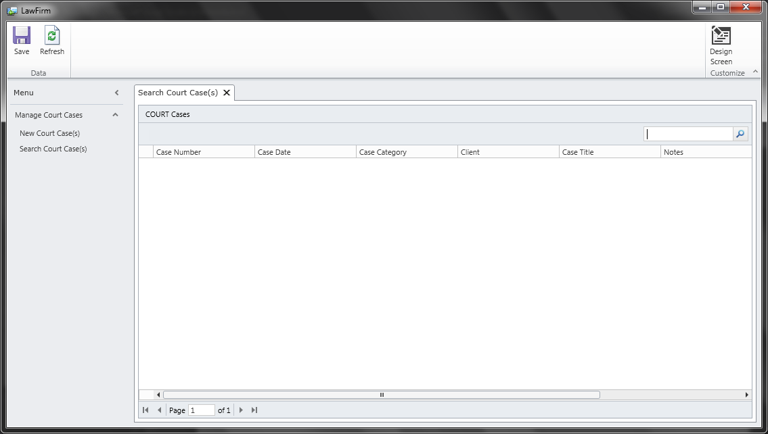

**Add New Court Case(s):**

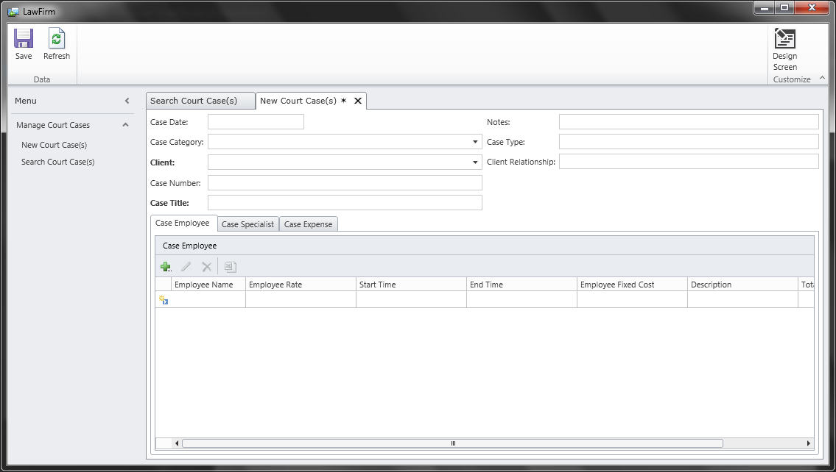

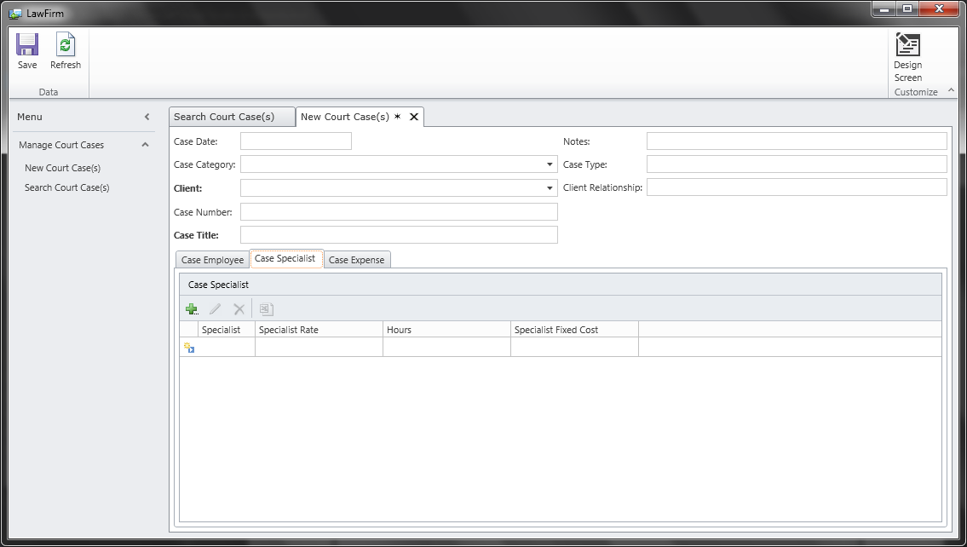

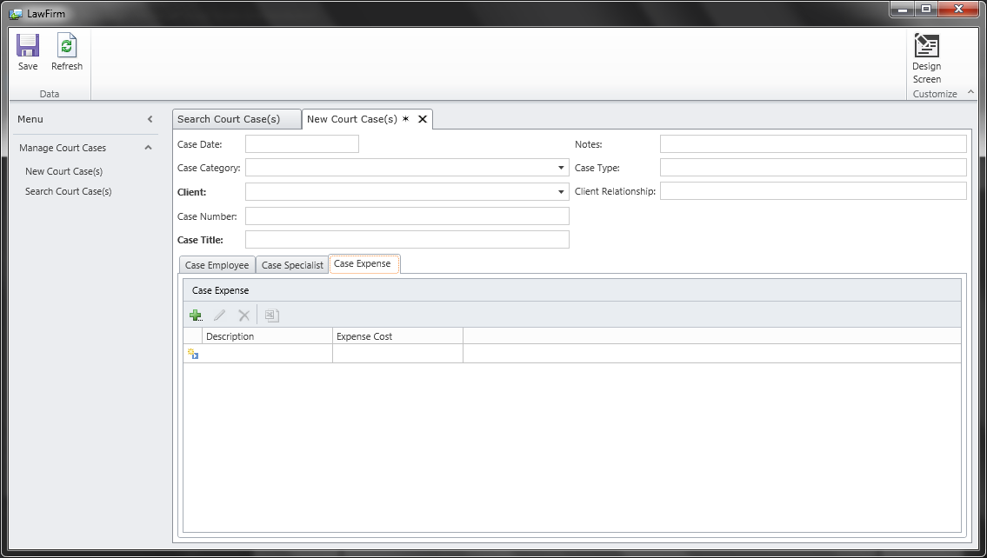

**Future Development:**

In the next following weeks, the team is going to focus on figuring out how to display calculated fields within the application. There is the matter of doing the logic for all the calculations that is required for the application to do. The report is what seems to worry the team the most, perhaps the hardest part of the project. The report shows all the data, and the remaining funds left from a case.

Below shows what the report should look like. This forum is what the attorneys turn in for court cases assigned by the county.

|  |  |  |  |
| --- | --- | --- | --- |
| **NAME AND ADDRESS OF VENDOR:                         PHONE:** | | For Court Use Only: | |
| **SUPERIOR COURT OF CALIFORNIA, COUNTY OF FRESNO**  **1100 Van Ness Avenue**  **Fresno, CA 93724-0002** | |
| APPLICATION AND ORDER FOR PAYMENT OF COURT APPOINTED VENDOR  **(Not to be used for court appointed special circumstance attorney claims)** | | | |
| **CASE NAME:** | | | **CASE NUMBER:** |
| **NOTE TO ALL VENDORS: COPY OF COURT ORDER APPOINTING VENDOR MUST ACCOMPANY THIS FORM.** | | | |
| **STANDARD RATE PSYCHOLOGICAL/**  **PSYCHIATRIC EVALUATION CLAIM:**  a. Date appointed:  by Judge  b. Evaluation date:  c. Type of evaluation:  d. Fee:  NOTE: If you have written**preapproval** for more than  the standard rate, fill out the expert services portion of  this form. | **COURT APPOINTED SERVICES (EXPERT, INVESTIGATOR, ETC.) CLAIM:**  (Provide Attachment A for itemization of services and mileage, and  Attachment B with original receipts for expenses.)  a.                       hours at $                         per hour                                 $ 0.00  b. Mileage (                   miles at $        per mile)                               $ 0.00  c. Expenses 0.00                                                                                      $ 0.00  **TOTAL                                                  $** 0.00 | | |
| **Signature of attorney of record required on Attachment A for expert or**  **investigator billing prior to submission.** | | |
| **COURT APPOINTED ATTORNEY DECLARATION AND CLAIM:**  I am an attorney at law duly admitted to practice in the State of California. I have not received compensation for this claim except as noted  below. I hereby make application for payment of fees as follows:  (See footnote * below before completing.)  A. Appointed on (date)                                               to represent (name)  (Client’s relationship to case:                                                                  )  B. This is the only billing for this case and legal services have been terminated  and required less than 3 hours - flat fee $240    $                                Expenses: $  C. Interim billing for services from                                             to  (If interim billing, date of prior billing:                                                                            )  D. Legal services terminated on or about (date):  E. Attorney’s fees: $                                                           Expenses: $***(other than $240 flat fee)***  **Total amount claimed for A through E** (Provide Attachment A for itemization of  services and Attachment B with original receipts for expenses):**TOTAL** $ 0.00 | | | |
| I declare under penalty of perjury that the foregoing is true and correct and that this declaration is executed on (Date):                               ,  at (Place)                                                                     , California.  (Type or print name)                                                                                                            (Signature of applicant) | | | |

FOR COURT USE ONLY:                                ORDER

The foregoing application has been considered and the court finds the following fees to be reasonable:

a. Fees: $

b. Expenses $

c. Mileage $

**TOTAL:** $

It is ordered that the total shown above in item 2c be paid by Fresno County Superior Court.

Dated: Judge of the Superior Court

*Declarations under penalty of perjury signed in California may be used in place of affidavits (CCP 2015.5).

Affidavits required when signed outside California.

**APPLICATION AND ORDER FOR PAYMENT OF COURT APPOINTED VENDOR FEES AND EXPENSES**